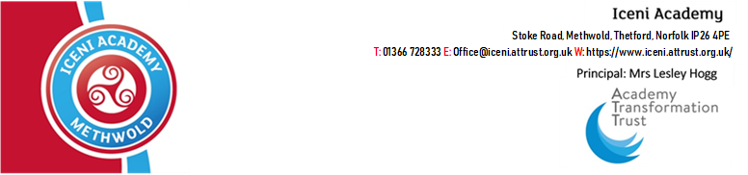

29th January 2021

Dear Parent/ Carer,
At Iceni Academy, we pride ourselves on the broad and balanced curriculum we offer to our students. As your child approaches Year 10, it is time for them to begin to influence their educational pathway by selecting their GCSE options subjects. They will study these subjects in Years 10 and 11, sitting their exams in Summer 2021.
All students will follow our core offer:
- GCSE English Language
- GCSE English Literature
- GCSE Mathematics
- GCSE Combined Science (worth two GCSEs)
- GCSE Citizenship
- PE (non-examined)
In addition to this, your child is able to select four option subjects that they would like to continue to study to GCSE level. These are arranged into three blocks:
Block A (choose one) | Block B (choose one) | Block C (choose two)
History  Geography | French  German  Build Up | Art and Design  Computer Science  Design Technology  Drama  Food Prep. & Nutrition  French  Geography  German  History | ICT  Mandarin  Media Studies  Music  GCSE PE  Sports Science  Religious Studies  Statistics  Triple Science

In Block C, your child will be asked to select five subjects they would be happy to study and we endeavour to give students two of their selected subjects. Some of these subjects may not run depending on uptake from the students, so it is important that your child is happy with all the selections they make.
We appreciate that this is both an exciting and slightly daunting prospect for many students, and so we are providing a wealth of resources to help students make their choices. These will all be posted on our website, at the following address: https://icenimethwold.attrust.org.uk/curriculum/options-process-2021/. This will include in the coming weeks a range of videos made by the teachers and Directors of Faculties, outlining what each GCSE option course entails. I also enclose here a copy of the options booklet, detailing more information about the subjects your child could go on to study with information for both Year 9 students and their parents/ carers.
Year 9 Parents’ Evening is taking place on Thursday 11th February 2020, and we encourage you to use this opportunity to speak to your child’s teachers about the various courses their faculties offer. Yours child’s Personalised Learning Tutor continues to be your first point of call, and Mr Falder, Head of Year 9, and I are also very happy to speak with you on the phone or via email if you have specific questions relating to your child’s options.
Parents Evening will look different this year, given that we are unable to host meetings in the academy because of the national lockdown. We will instead be using an online platform, https://icenimethwold.schoolcloud.co.uk/. Please visit this website and enter your child’s details to login to the platform and book appointments with your child’s teachers. Please find alongside this letter and the options booklet a guide to booking appointments on the SchoolCloud system.
We have set up an online web form where all students will select their option subjects. You will be able to find the link to this on our website (https://icenimethwold.attrust.org.uk/curriculum/options-process-2021/) from Friday 12th February 2021. We ask that this is please completed no later than Friday 26th February 2021. Students can complete this form at home or in the Academy.
If, having read the options booklet, you have any questions or would like any further help in supporting your child through the option process, please do not hesitate to contact your child’s Personalised Learning Tutor, Mr Falder or me and we will be more than happy to help.
Yours faithfully,
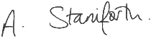
Miss A Staniforth
Assistant Principal

